
East West University
Department of Computer Science & Engineering
Plot No-A/2, Main Road, Jahurul Islam City, Aftabnagar, Dhaka-1219

Lab Manual
Course : CSE -105
Credit Title : Structured Programming
Instructor : Md.Shamsujjoha (MSJ)

Lab-1: Introduction to C Programming

Aims: By the end of the workshop you should be able to understand: -

- What is C programming?
- How to start and write a simple C program
- How to save a program
- How to compile, build (link) and execute the program

What is C programming?
C is often called a "Middle Level" programming language. This is not a reflection on its lack of programming power but more on a reflection in its capability to access the system's low-level functions. Most high-level languages (e.g. Fortran) provide everything the programmer might want to do because they are already built into the language. A low-level language assembler provides nothing other than access to the machines basic instruction set. A middle level language, such as C, probably doesn't supply all the constructs found in high-languages - but it provides you with all the building blocks that you will need to produce the results you want. C is proven a very popular language for developing systems applications such as operating systems, compilers and communications.
Why use C?
Mainly because it produces codes that run nearly as fast as codes written in assembly language. In recent years C has been used as a general-purpose language because of its popularity among the programmers.
History of C
In 1972 Dennis Ritchie at Bell Labs writes C and in 1978 the publication of The C Programming Language by Kernighan & Ritchie caused a revolution in the computing world. It is hoped that newcomers will find C is a useful and friendly language. Care must be taken in using C. Many of the extra facilities, which it offers, can lead to extra types of programming errors. You have to learn to deal with these in order to be a good C programmer.

Using Microsoft Visual studio 6.0.
Welcome to Visual C++ -- one of the most powerful and popular general-purpose programming language. It is an extension of C programming language. C is originally developed by Kerninghan and Ritchie at Bell Telephone Laboratories in 1970’s.

Starting Microsoft Visual C++ 6.0
The software and the presentation file given in the 1st class help you to install Visual C++ 6.0 in your windows machine. From now on, we will consider all of you have already installed Visual C++ 6.0 on your personal machine. However if you are still in problem on installation of Visual C++ 6.0 do not hesitate to knock me.

For today’s lab follow the following steps:

1. At the desktop, click on the Start button.
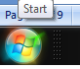
Figure 0.1

2. Select All Programme
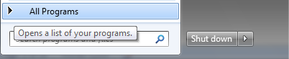
Figure 0.2

3. Select Microsoft Visual Studio 6.0 option then Microsoft Visual C++6.0 option.

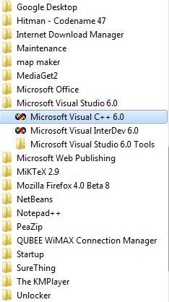
Figure 0.3

4. You will see the main screen (figure 1.1).

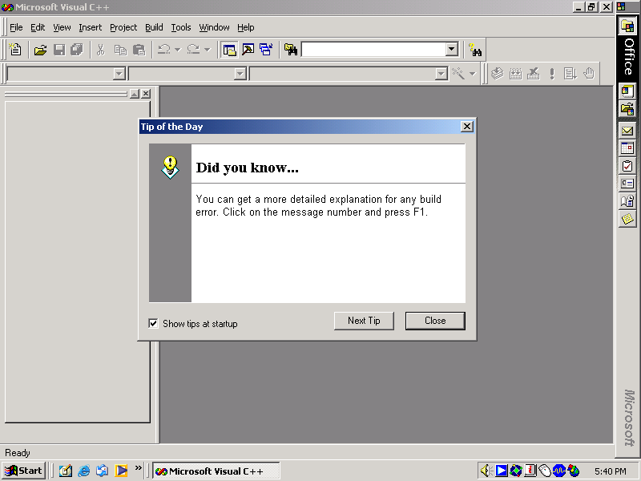
Figure 1.1

4. Click Close.

5. After that you can see the blank interface like Figure 1.2.

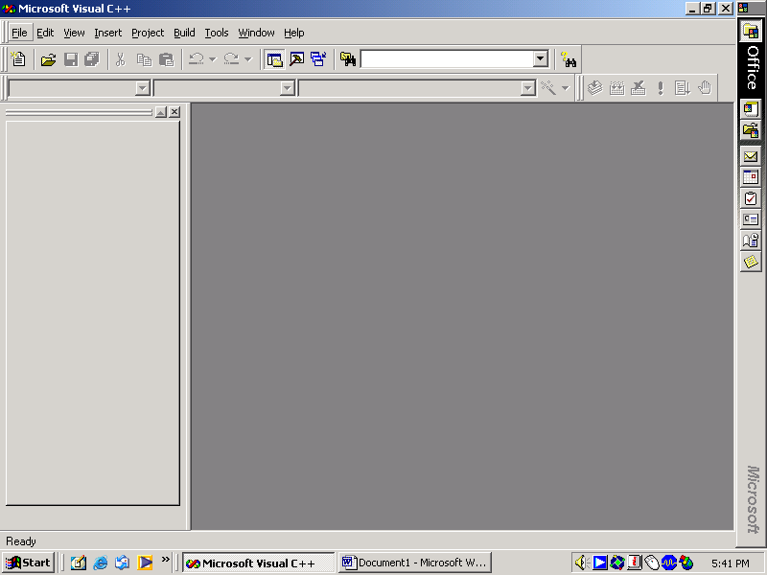
Figure 1.2

6. In the main screen select File menu, then click New. The New dialog box appears. You can see the screen like figure 1.3

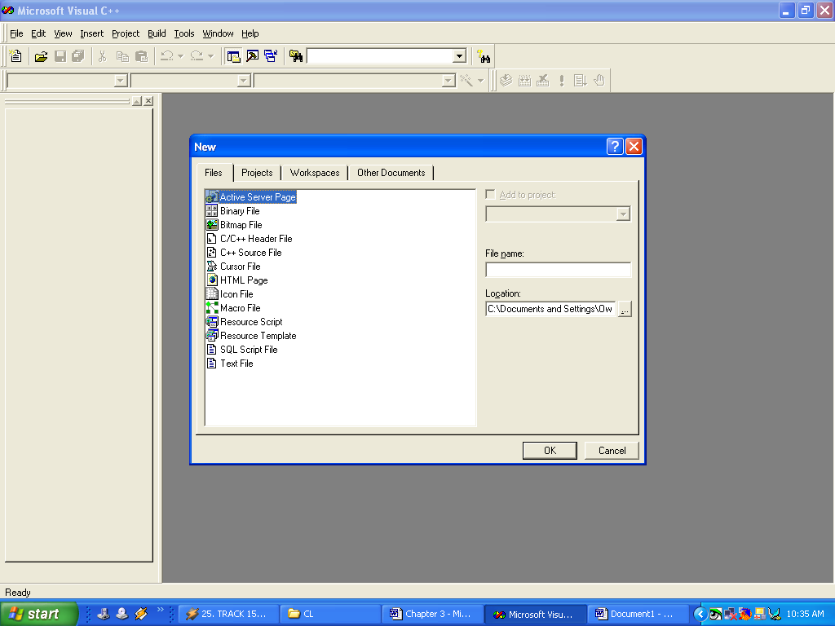
Figure 1.3

7. Select File at the New dialog box. Then, select C++ Source File and click OK. The screen in figure 1.4 will appear. This is a blank text editor window (this is where you type in your code).

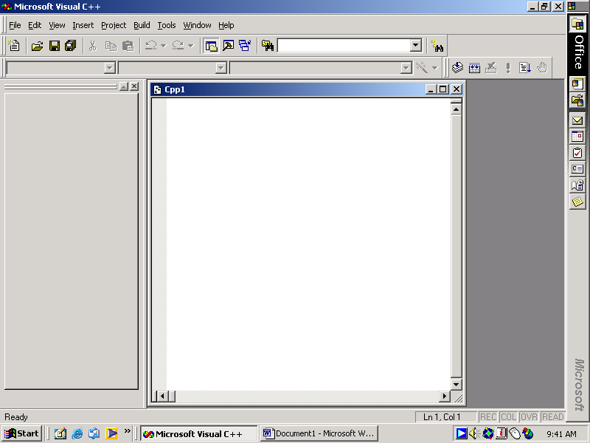
A blank text editor

Figure 1.4

Creating a program

1. Type your C source code in the text window as follows.

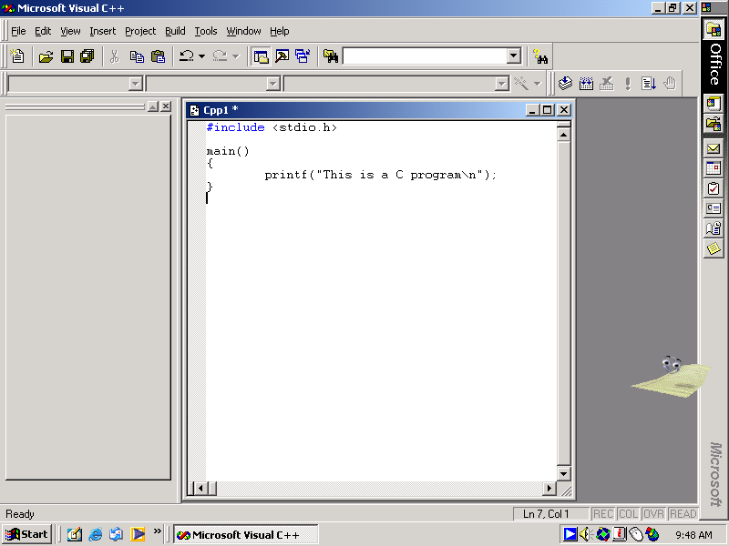
Figure 1.5

Explanations: -
Every C program contains a function called main. This is the starting point of the program.
- #include <stdio.h>
Allows the program to interact with the screen, keyboard and file system of your computer. You will find it in the beginning part of almost every C code.
- main()
{
}
Declares the starting part of the function, while the two curly brackets show the starting and ending points of the function. Curly brackets in C are used to group statements together in a function, or in the body of a loop. Such grouping is known as a compound statement or a block.
- printf(" C programming is interesting\n");
printf prints the words on the screen. The text to be printed is enclosed in double quotes. The \n at the end of the text tells the program to print a new line as part of the output.
Most C programs are in lower case letters. C is case sensitive.

Save a program

1. From the menu bar, select File and then select Save As.

2. Select the appropriate directory. In lab session, we will save all our exercise in directory desktop. So, just crate a new folder in desktop. Then, save in that new folder (new folder can be any name).

3. Type the name of the program file
C program

Example: program1.c

You must save all source code in C extension (all in file_name.c). Click Save button.

Compiling a program

1. From the menu bar select Built and then select Compile program1.c or just click the compile icon. See below figure:

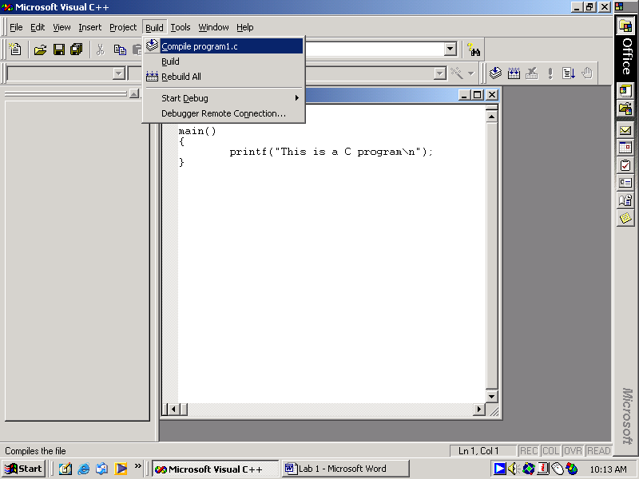
Compile
Icon
Figure 1.6

You will get a message asking whether you need a workspace. Click Yes button. Visual C++ will create default workspace and then build your code. This will produce an .obj program file. It does not have proper link with the library (built-in library) yet.
If there is any program error or warning message, visual C++ will display it in the message window (shown in Figure 1.7). If there is no error or warning, you can then execute your program.

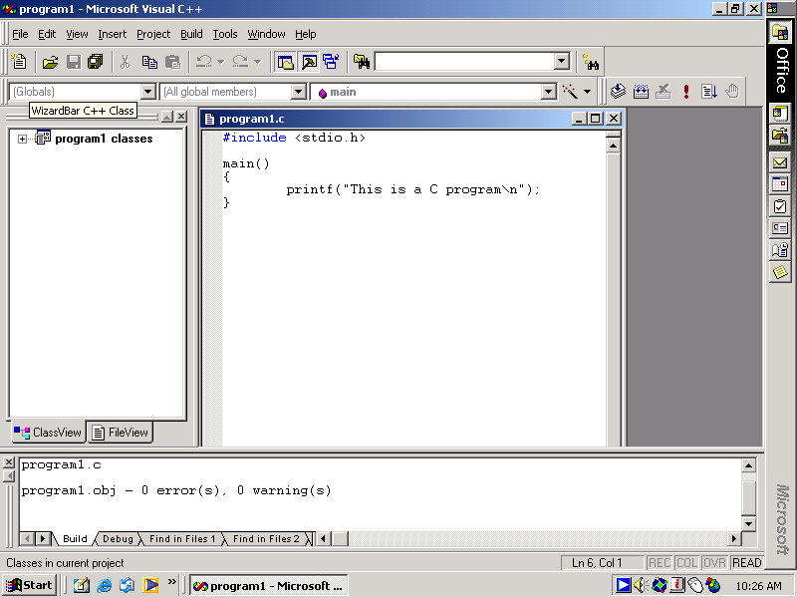
Workspace
Message window
Figure 1.7

Executing (build) a program

- From the menu bar, select Build and then select Build program1.exe. or you can click build icon. See figure 1.8: -

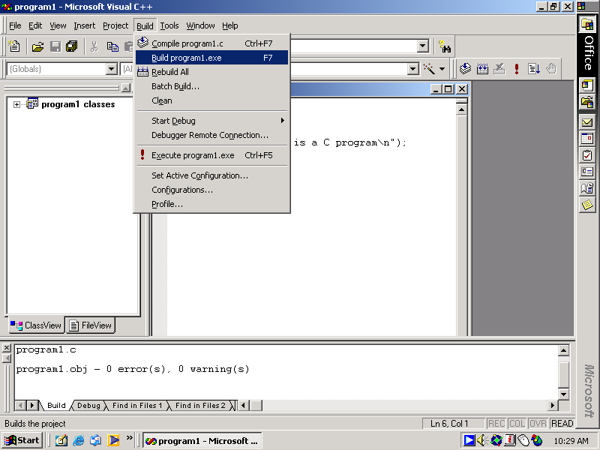
Message window
Build icon
Figure 1.8

2. Now, the program code is of .exe file extension. You can see the file extension can at the message window.

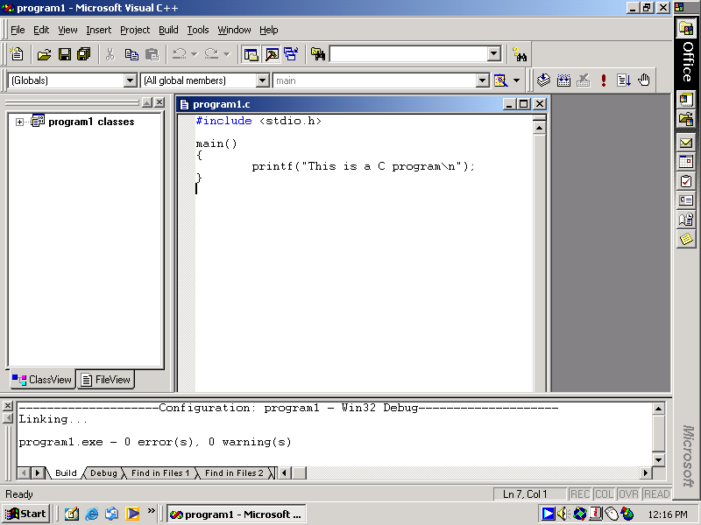
Figure 1.9

Running a program.

1. From the menu bar, select Build and then select Execute program1.exe. or you can click the execute program icon .See Figure 1.10:-

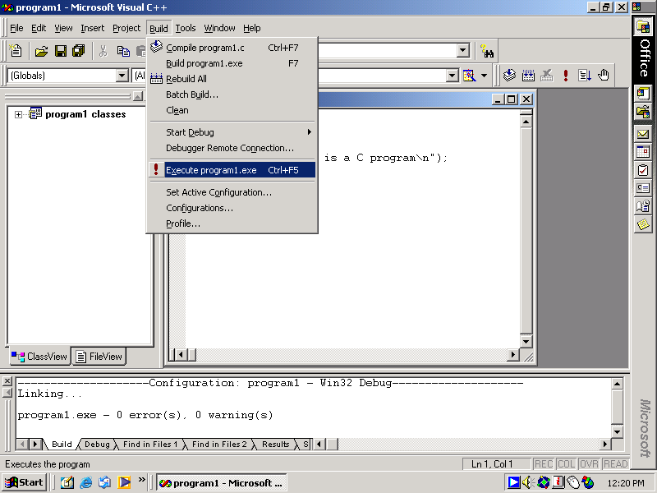
Figure 1.10

2. Now, you can see the output. The output screen contains the printed results. Press any key to return to the program.

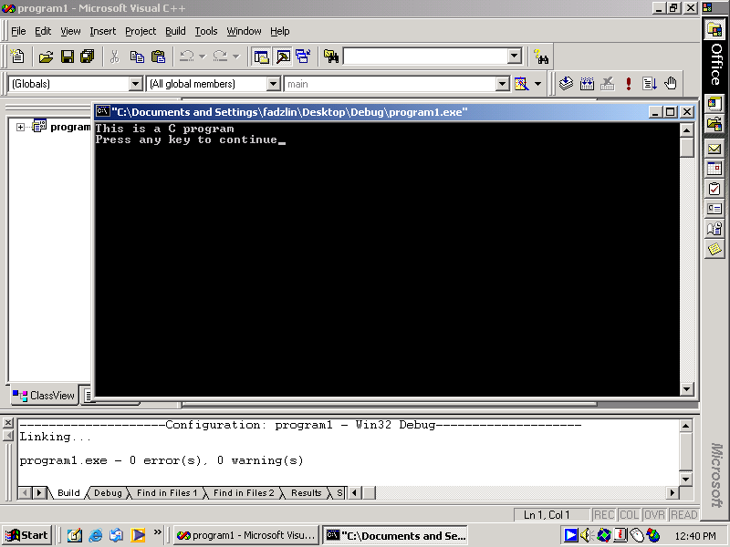

Exercise on lab 1

- Type the following program

#include <stdio.h>
int main (void)
{
printf (“****Welcome to my C lab session \n****”);
return 0;
}

- Save as lab1.c
- Compile the program. After that, check what the files present in the directory are now. List them.
- Build the executable file. After that, check what the files present in the directory are now. List them.
- Run the program. What is the output?

- Go back to the program and replace the line printf (“****Welcome to my C lab session \n****”); with the following lines
printf (“****Welcome “);
printf (“to my C lab session \n****”);
Then repeat step 2 until 5. What is the output now?

Home Work:

Above tasks help you to understand the functions of \n and printf. Now, for the next week your there are 9 home task for you which is given below.

Hello World  Task 1 | Hello  World  Task 2 | H  e  l  l  o  Task 3
*  **  ***  ****  Task 4 | ****  ***  **  *  Task 5 | *****  * *  * *  *****  Task 6
*  ***  *****  *  *  *  *  *  Task 7 | *  ***  *****  *  *  *  *  *****  ***  *  Task 8 | *** *** ***  * * *  * *** ***  * * *  *** *** ***  Task 9

You have to print the above TEXT using printf and \n only.

Reminder: Next week no student will be allowed to enter into the lab without completion of the above home tasks. We also vigorously opposed to the academic dishonesties, as it seriously detracts from the education of honest students. In the completion of your home works, it is impermissible to discuss a general method of solution with other students, or to make use of online resources. In case of any problem, inconsistency and errors in coding knock your Instructors/teachers. We are here to help you and to remove your confusions.
Thanks
Maheen Islam, Dr. Taskeed Jabid and Md. Shamsujjoha
Faculty members, Department of Computer Science & Engineering
East West University
Plot No-A/2, Main Road, Jahurul Islam City, Aftabnagar, Dhaka-1219
Email: maheen@ewubd.edu, tasked@ewubd.edu and dishacse@yahoo.com

